Correlation Plot:

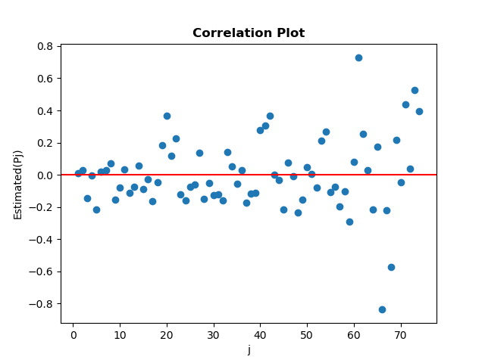

Most of the plotted points are near the horizontal line regardless of some outliers that is situated far from the horizontal line. So, we can say observations are independent.

Scatter Diagram:

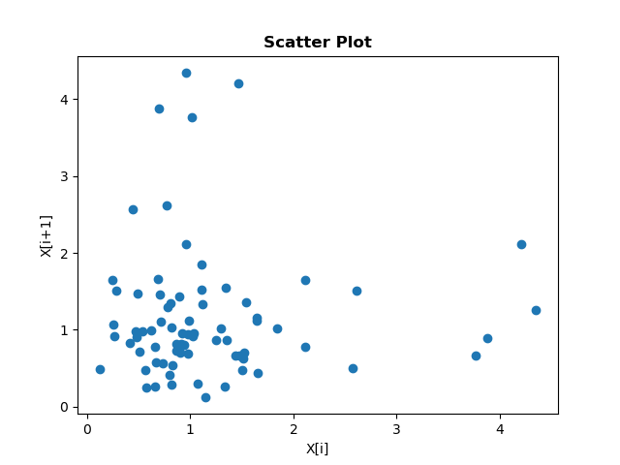

Here we can see this graph is sparse and does not show any positive or negative slop. So, we can say observations are independent.